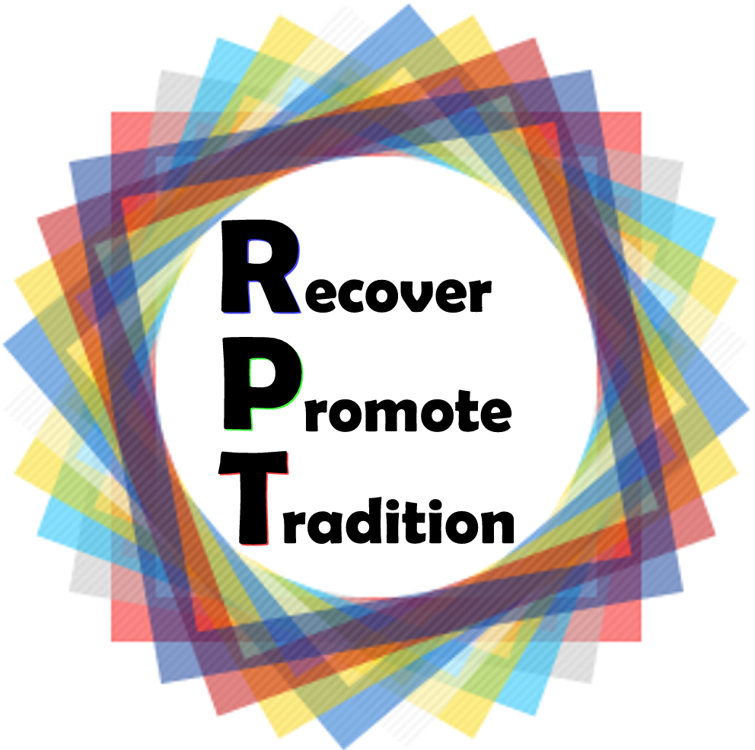


RE-PRO-TRADITION

DRAFT PROGRAMME OF GRUNDTVIG MEETING
ROMANIA, OCTOBER 2012

DAY 1 | DAY 2 | DAY 3 | DAY 4 | DAY 5
ARRIVALS | BREAKFAST | BREAKFAST | BREAKFAST | DEPARTURES
ARRIVALS | Introduction to the programme, its goals and objectives  (ecah country presents its materials/ power point presentations)  Getting to know each other | Workshop – crafts  Presentation of Romanian crafts –  Workshop involving adults and teeangers working together to make different handy made objects | Trip – a visit ot the Bran Castle also known as Dracula Castle (spend the night in Moeciu a mountain resort near Bran)  Lunch  Worshop – Romanian traditions in Bran region  Evaluation / feed-back | DEPARTURES
ARRIVALS | LUNCH | LUNCH |  | DEPARTURES
ARRIVALS | Workshop – Art teachers and students will help the participants to make some Romanian handicrafts  Free time | Visit the Art an History Museums as well as Romanescu Park, the second natural park in Europe |  | DEPARTURES
ARRIVALS |  | DINNER |  | DEPARTURES
ARRIVALS |  | Traditional dinner |  | DEPARTURES

