WEDNESDAY 24th October 2012
15:00 pm We meet with KC English team at the OTP airport. And after minutes we meet with Simona and Elena. We go to Craiova in a minibus.
19:00 pm We arrive to Craiova. Hotel Jiul, check in.
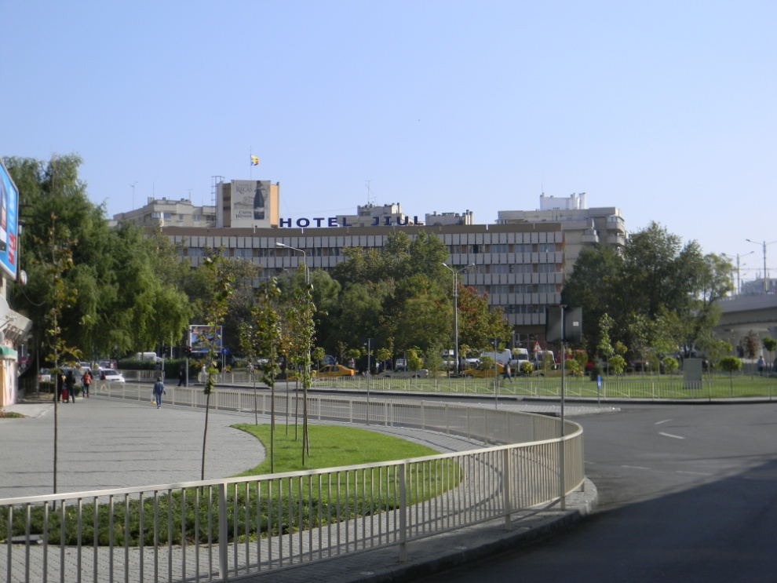
THURSDAY 25th October 2012
9:00 Hotel Jiul. Transport to Colegiul National Stefan Velovan.
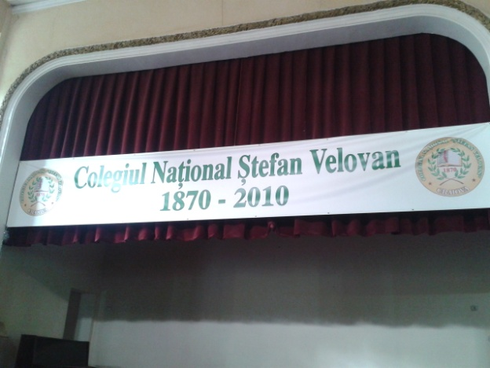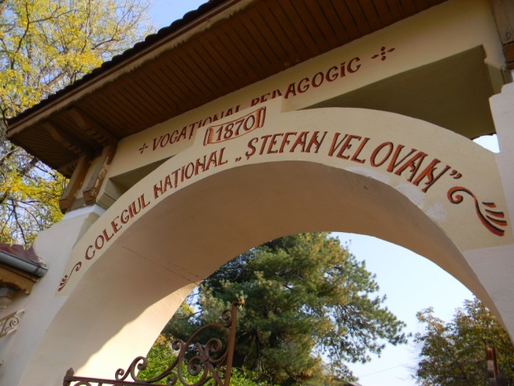
9:30 In the school. Official presentations. We know all the Romanian team and the principal of the school. We know the Slovakian team. Large team indeed. We are waiting polland team.

10:00 Romanian team decides we visit the school in order to give time to Poland team to arrive to school.
11:00 First stop in the visit of the school is the school museum. 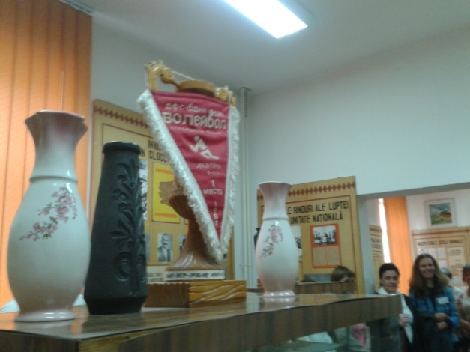
11:10 We visit a lot of classrooms of the school. We know students of all ages. 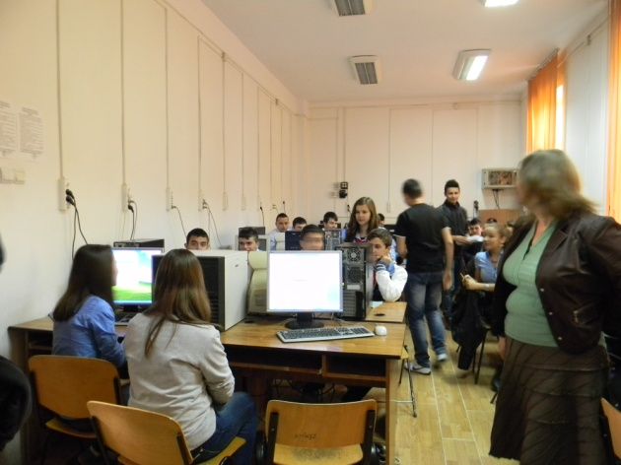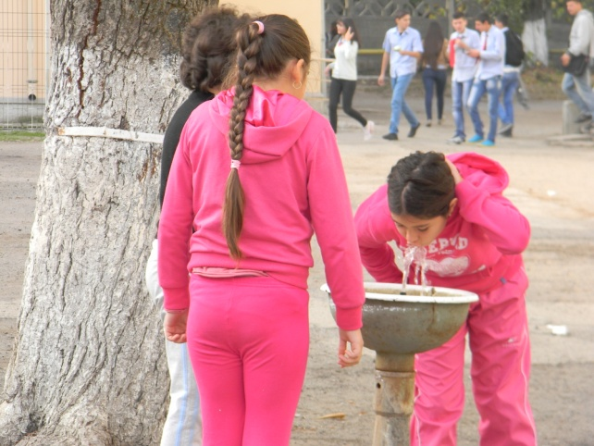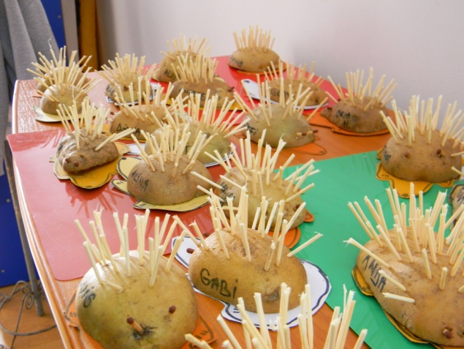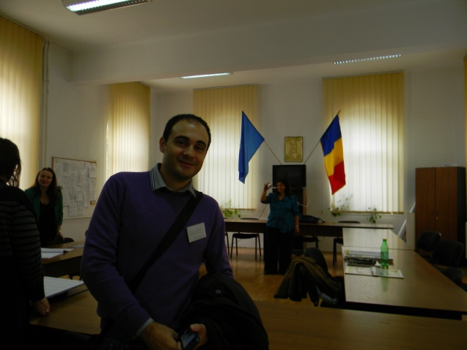

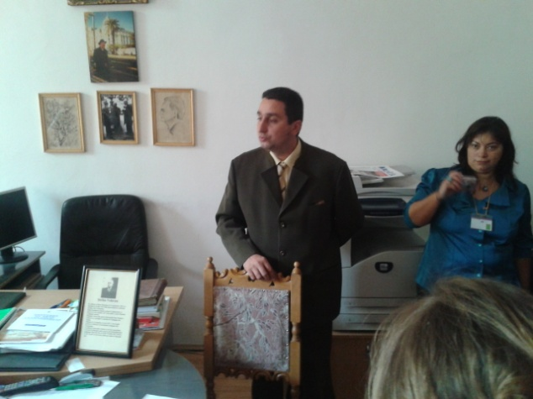
Speaking with the principal of the school
11:20 Coffee brake
11:30 Poland people arrives
11:50 We start our presentation about Handycrafts made of white palm. It continue over 10 minutes. After the presentation we show some real white palm handycrafts from spain. We give a curly white palm handycraft to Colegiul Stefan Velovan and we give some lapel white palm handycraft to the assistents.
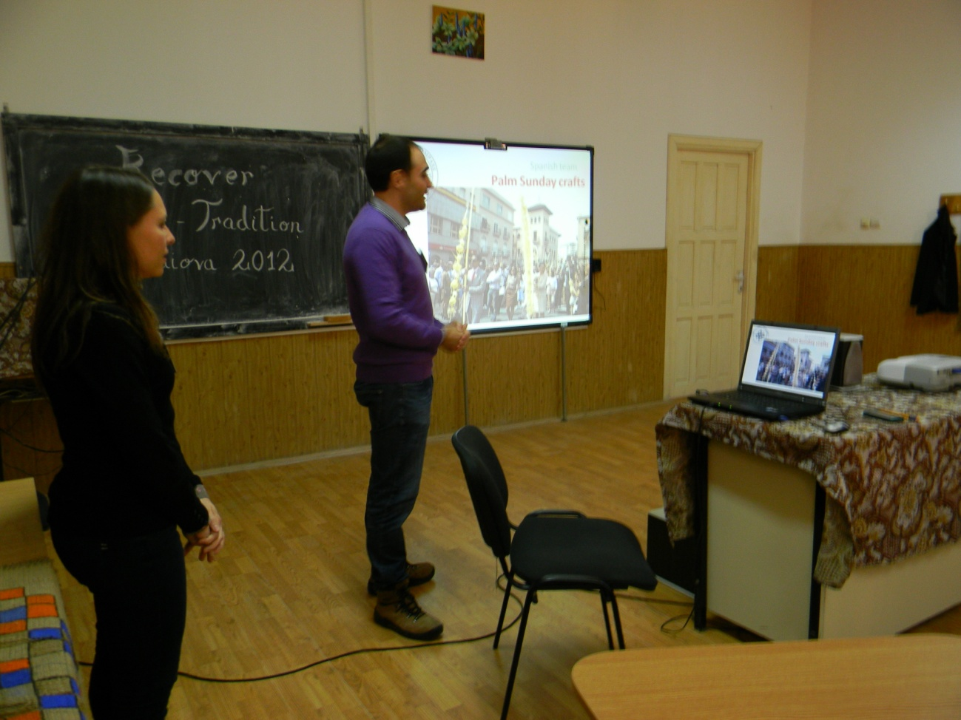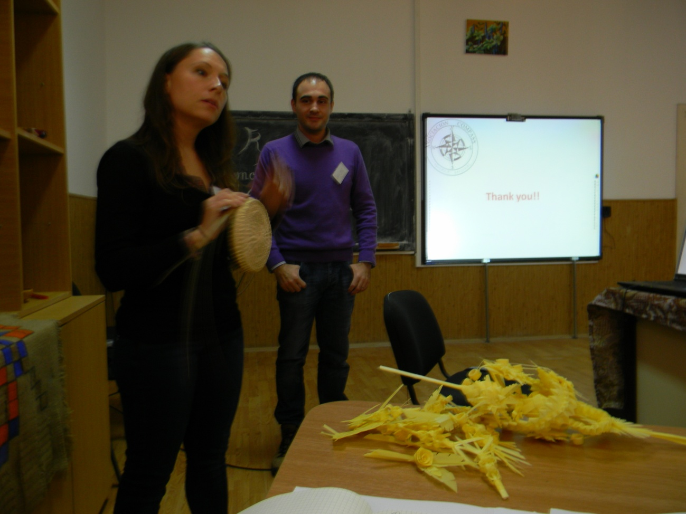
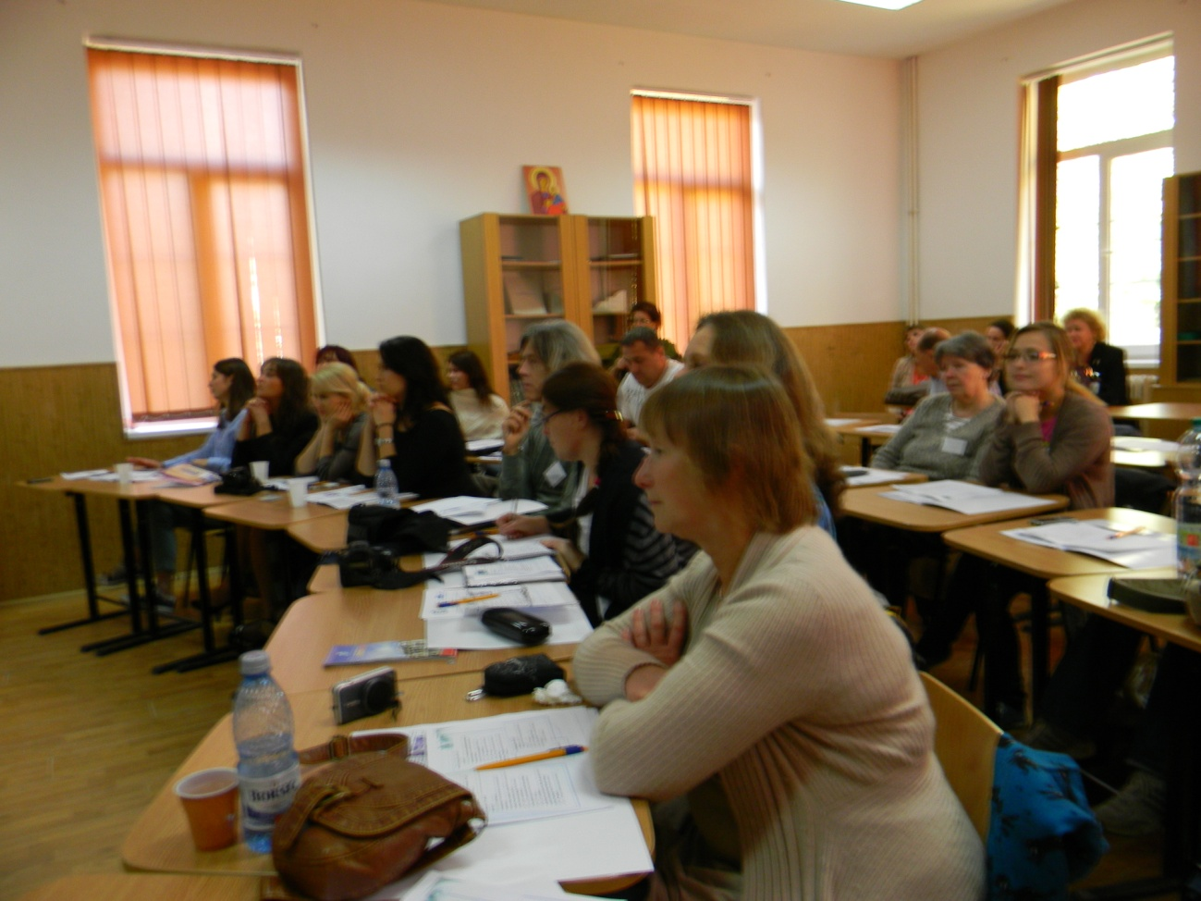
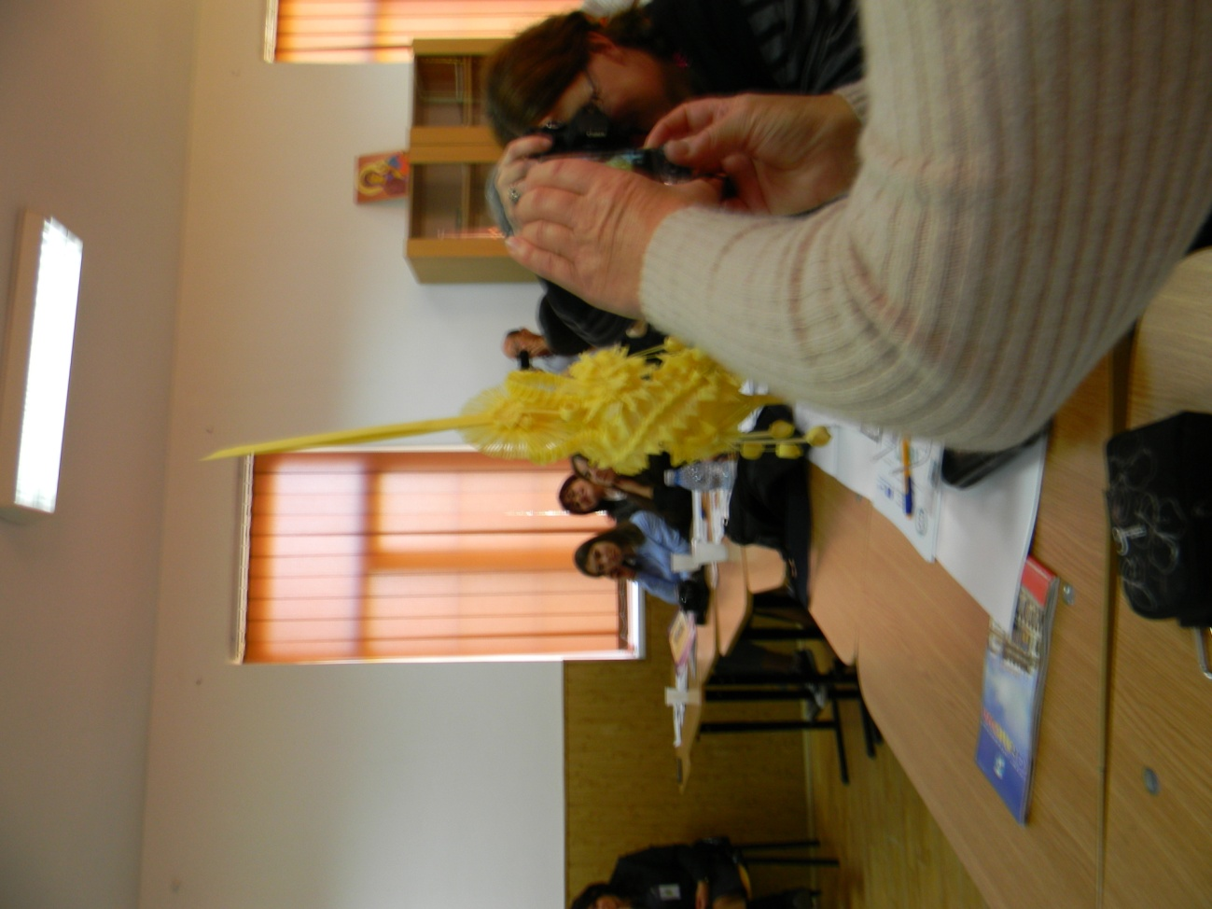
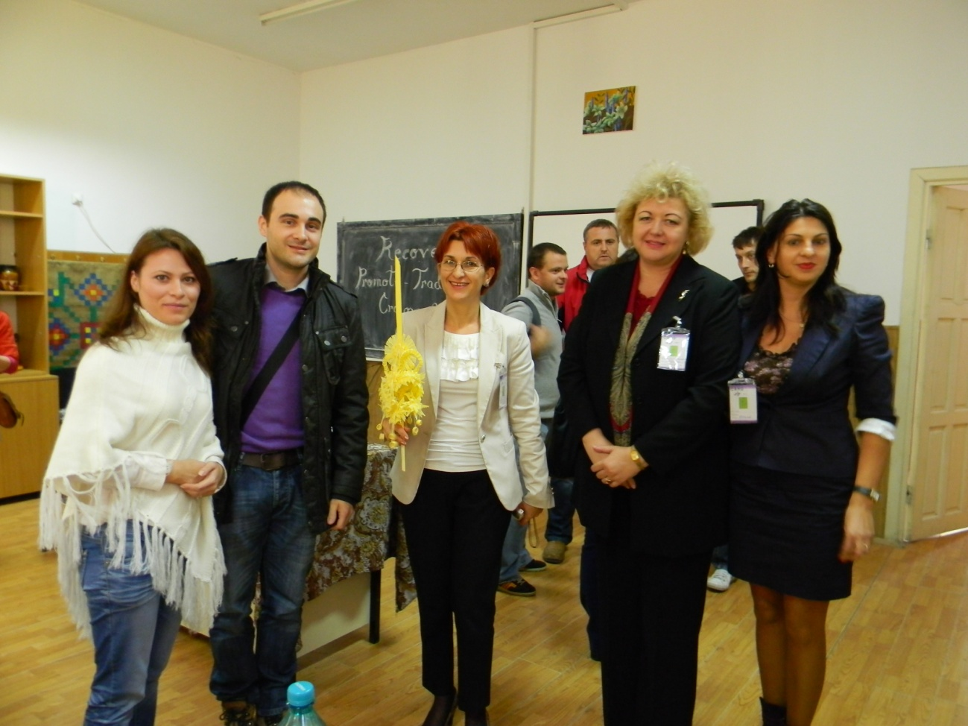
12:10 Poland people start their presentation. They talk about art and crafts in Poland. They give some books.
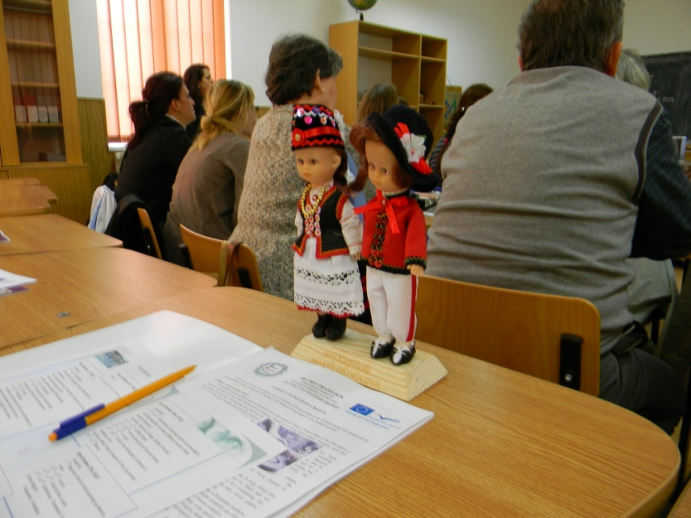
Typical Poland clothes
12:15 English group from KC. They speak about their organization, about their art projects.
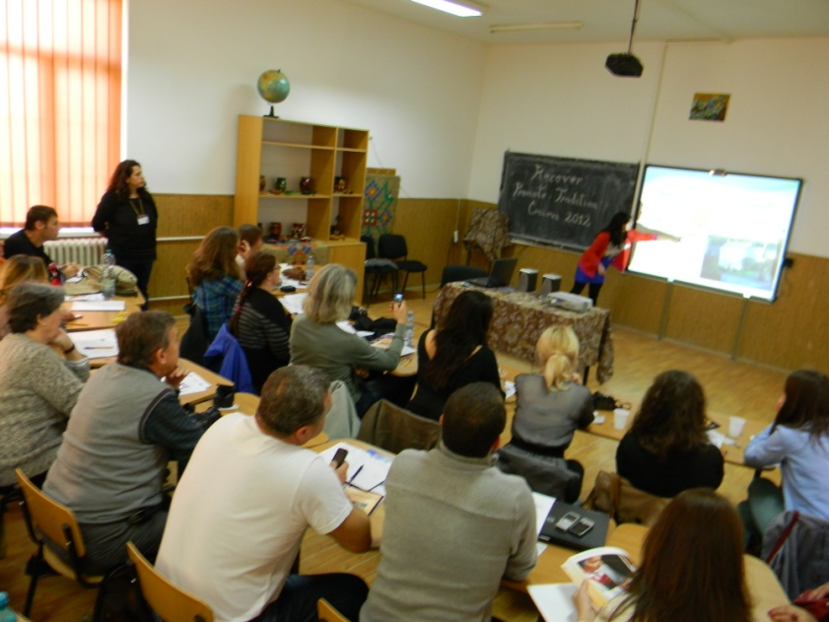
Hetty Kalantar showing us her organization (objectives, activities, where, …).
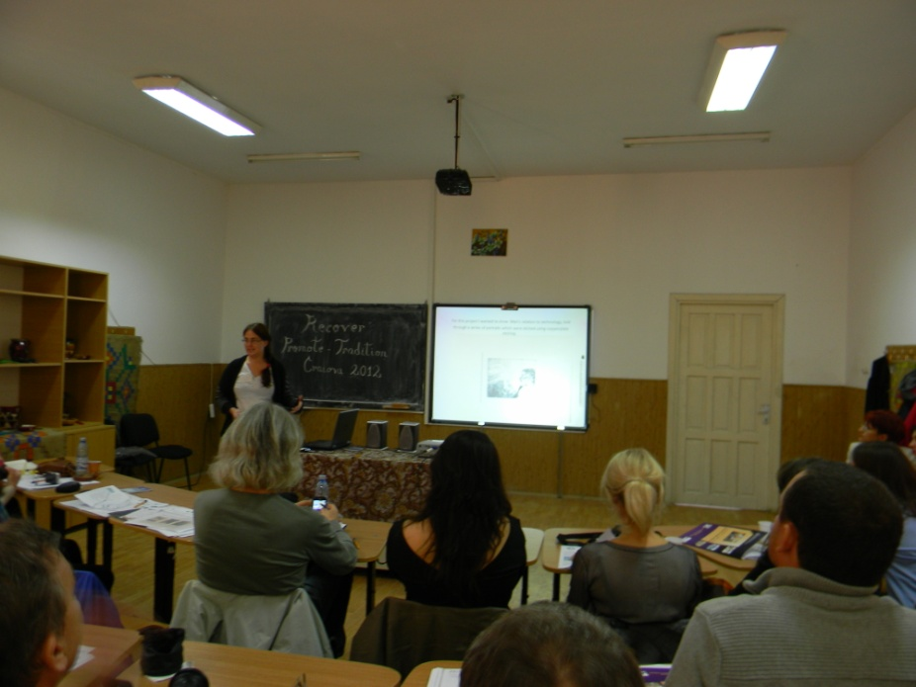
Zoe Clarke showing us a special form of making art.
12:45 Romanian team shows their presentation. They talk about Romanian crafts in general.
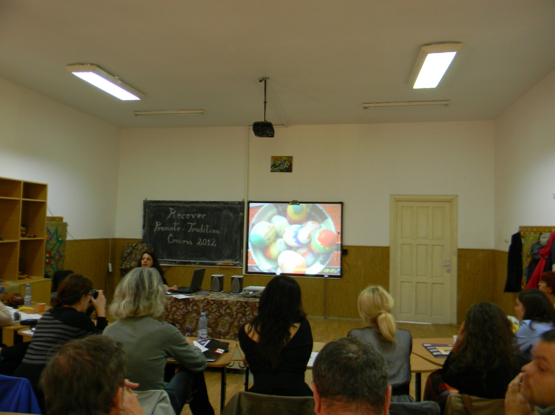
Simona showing us painted eggs traditional of Romania.
13:00 Slovakian team shows their presentation. They talk about Slovakian crafts in general.
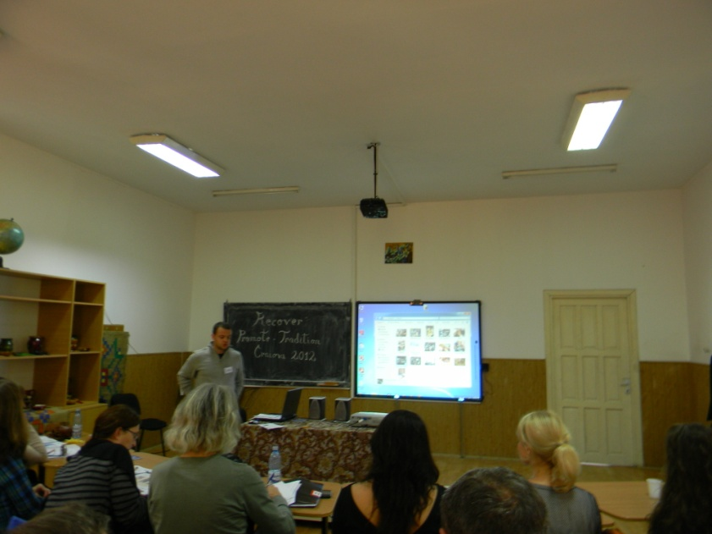
Tibor Rakoczi speaking.
13:30 Lunch time.
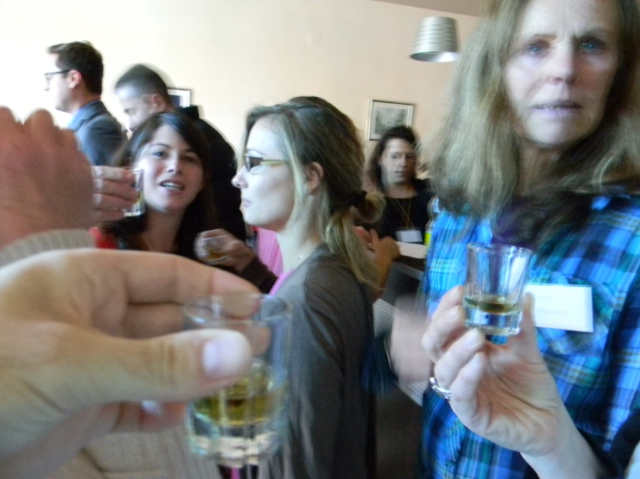
16:00 Workshop. Painting ceramic.
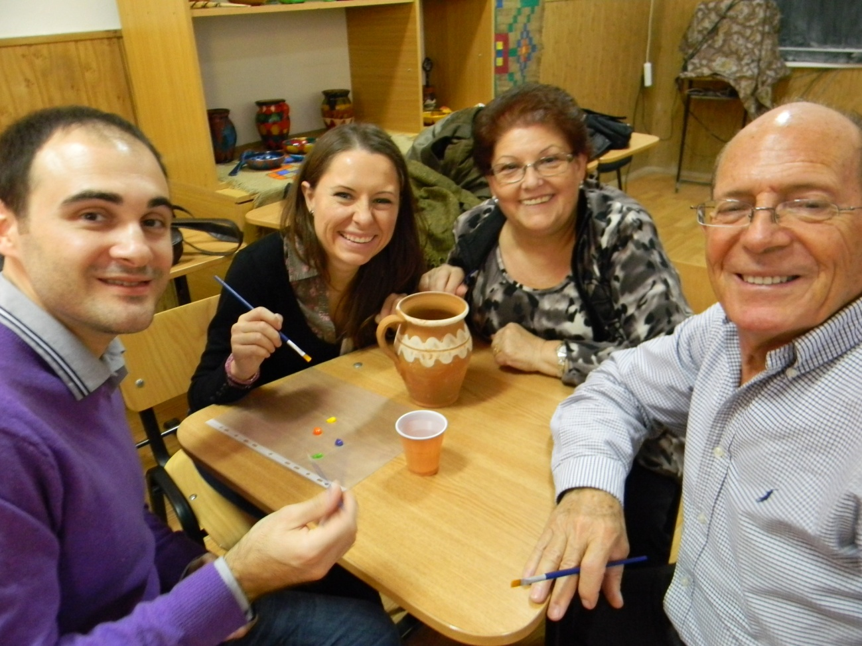
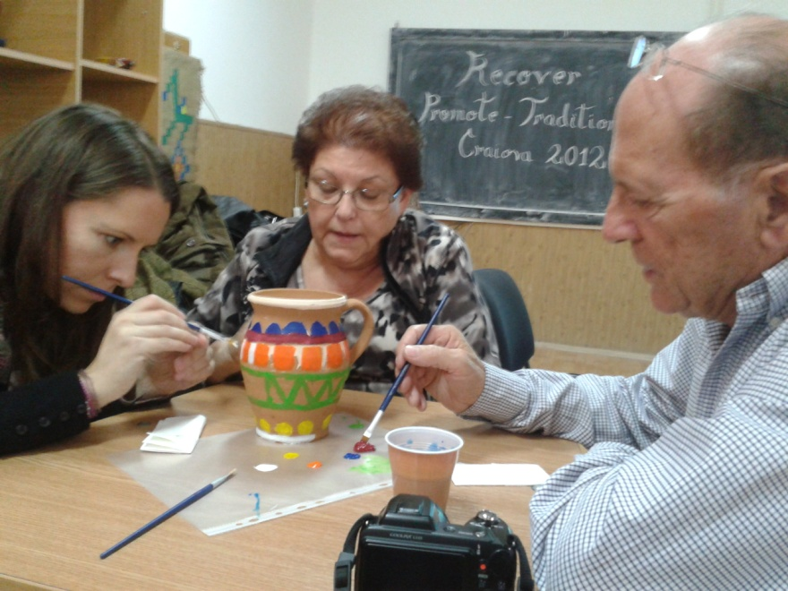
Spanish team painting a clay jar.
19:30 Traditional dinner.
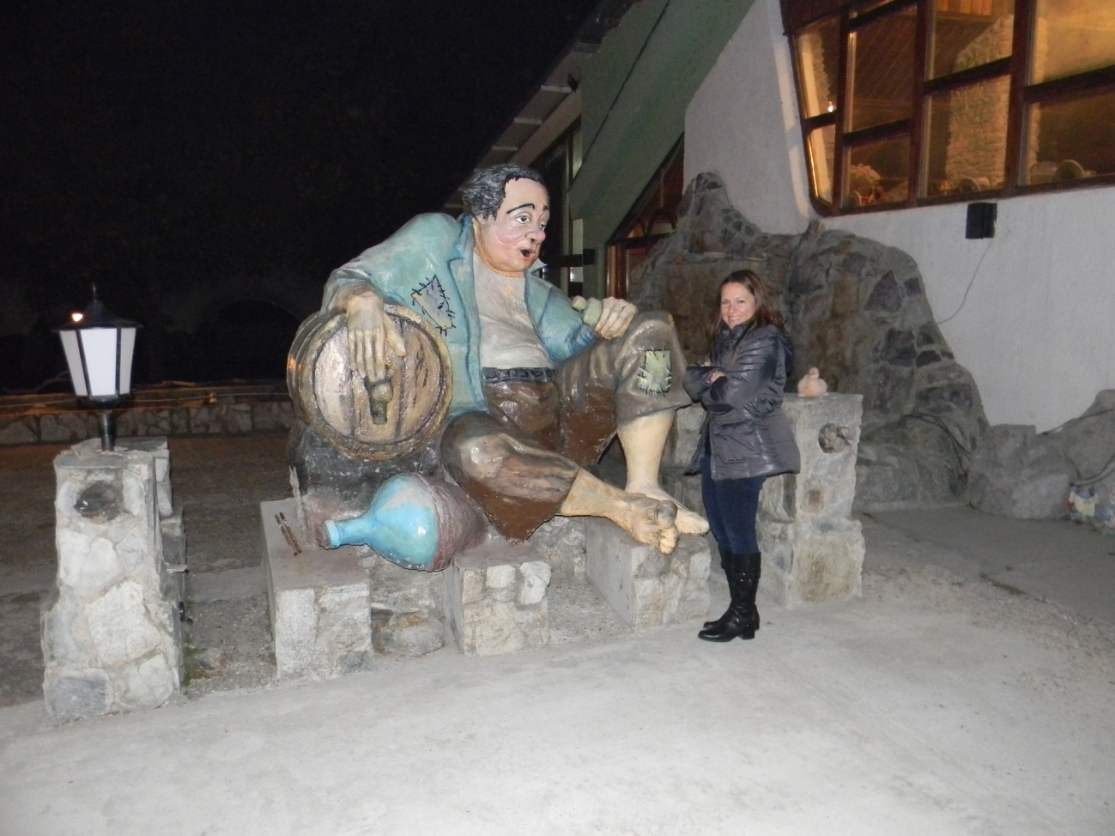
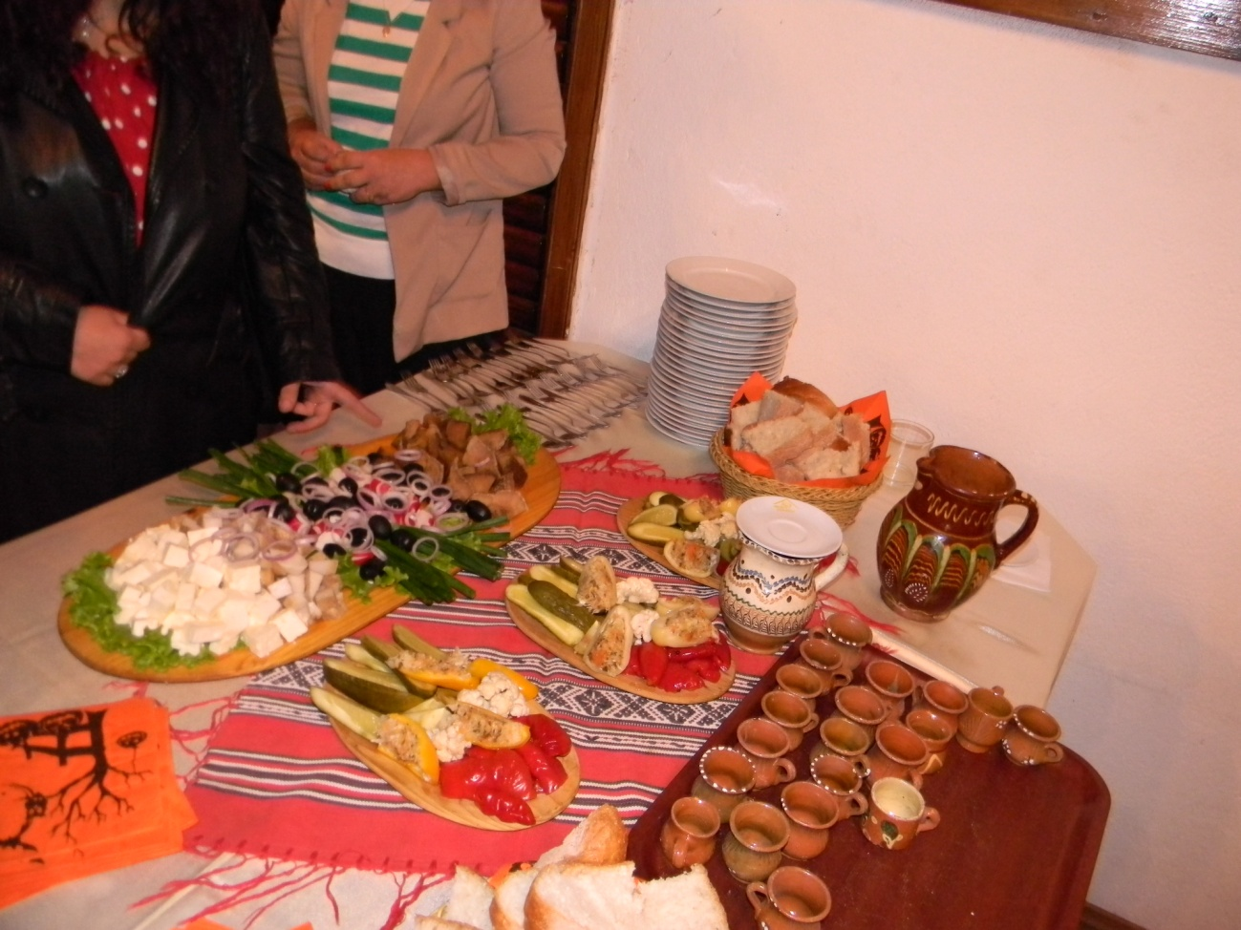
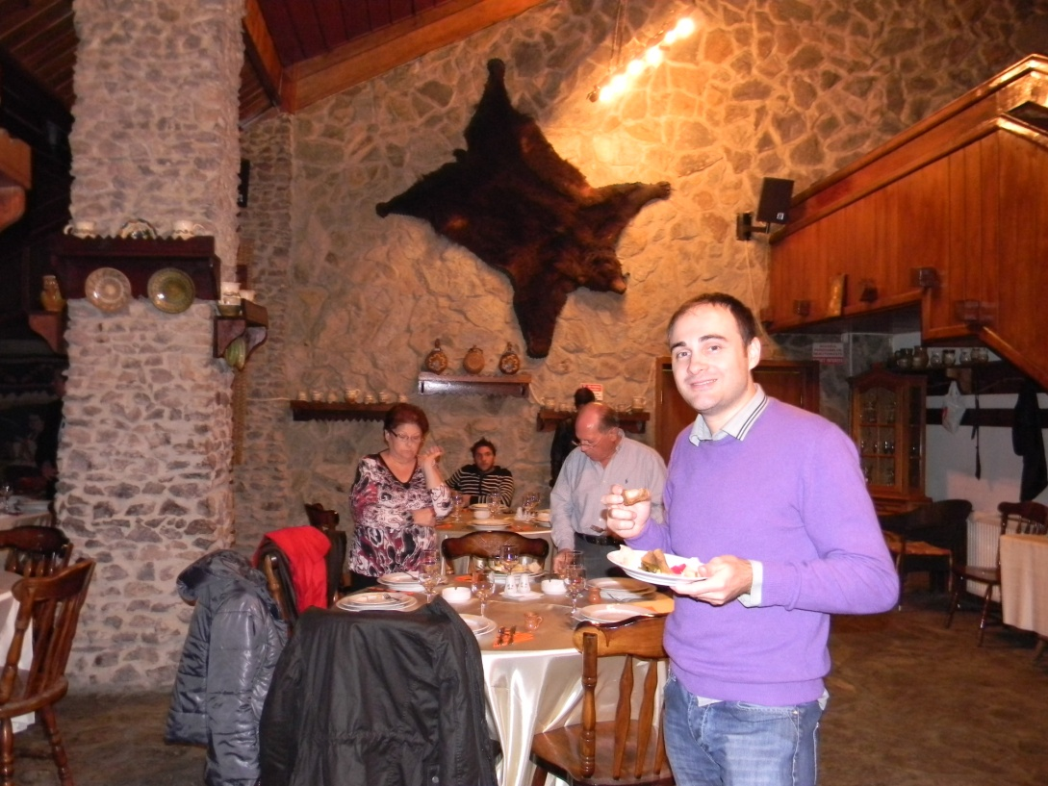
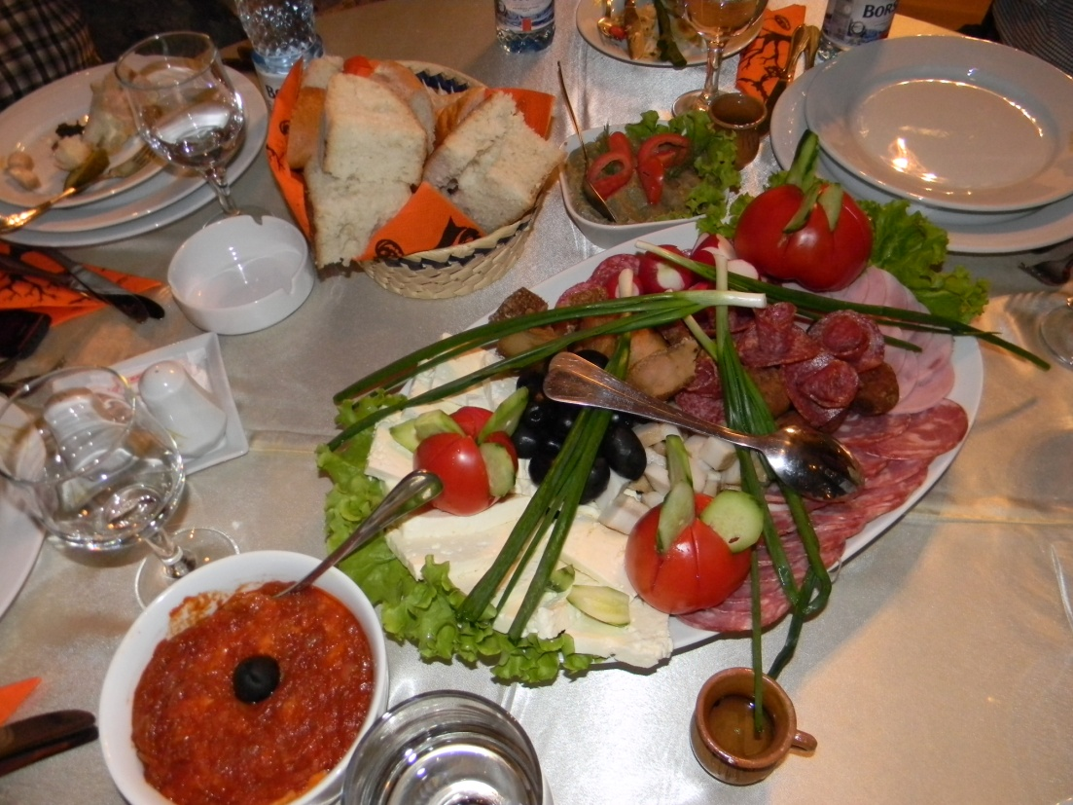
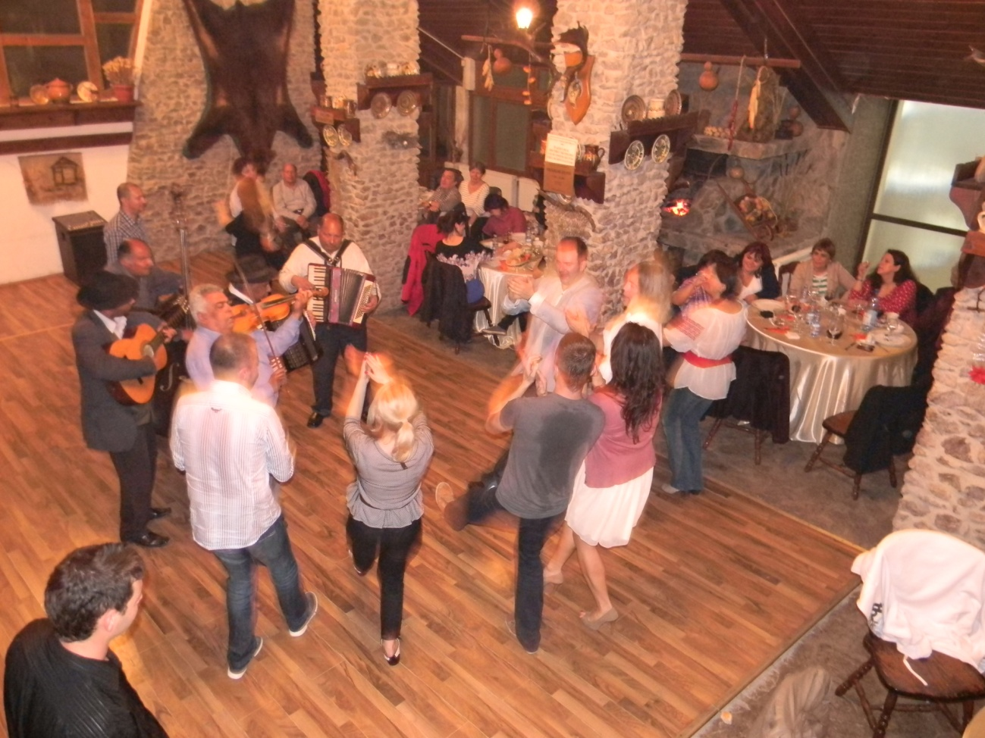
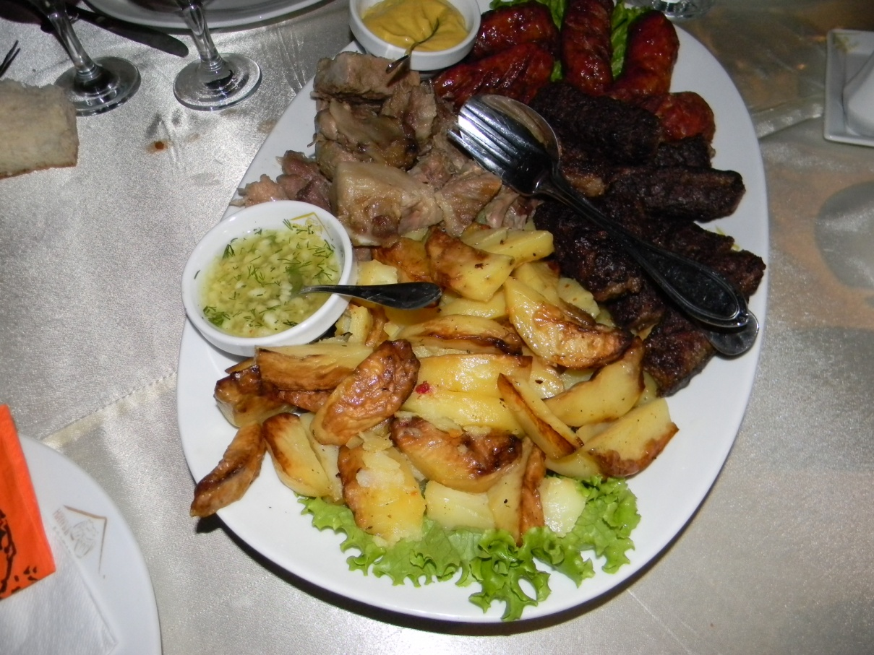
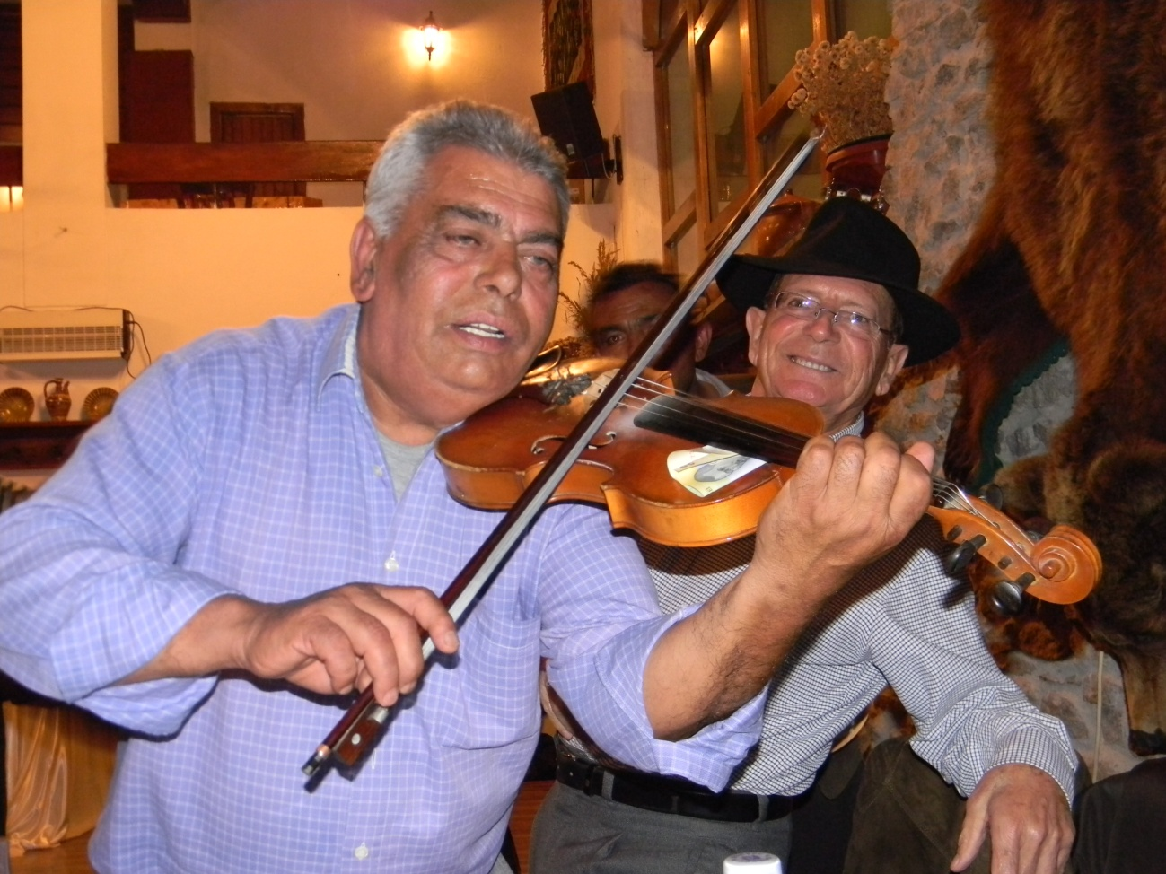
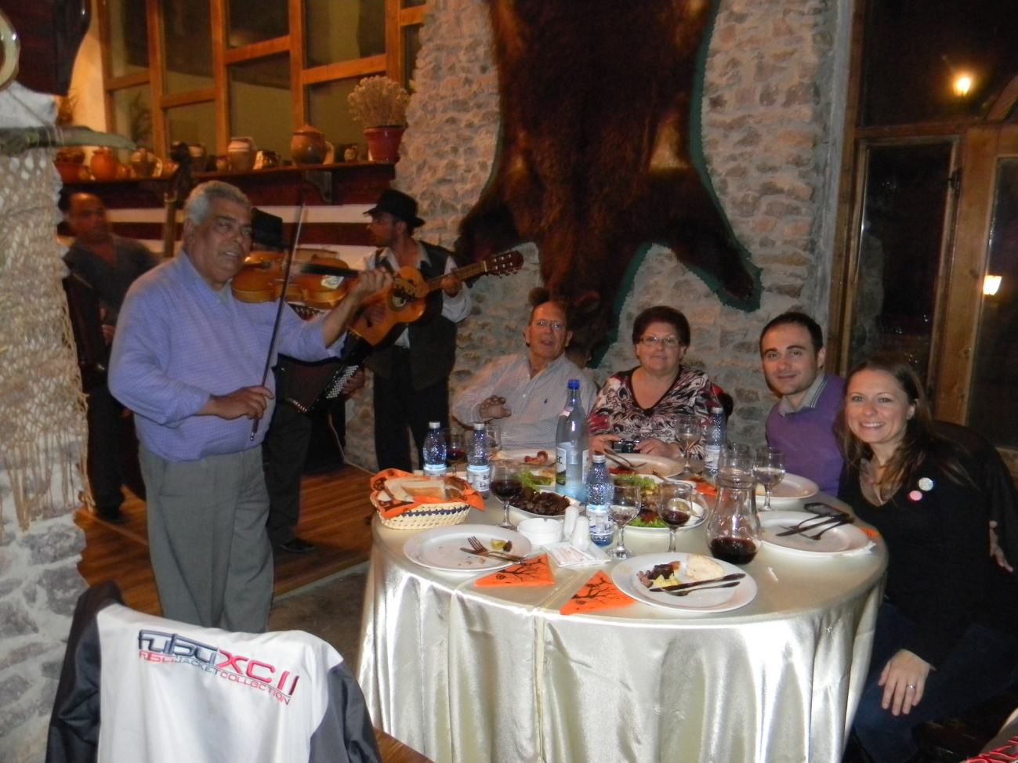
FRIDAY 26th October 2012
9:30 Colegiul Stefan Volvan. We see t-shirts made by students. We start a second and last workshop. This is about painting over cloth. We paint a palm tree. We exchange our artwork paint with Slovakian people.
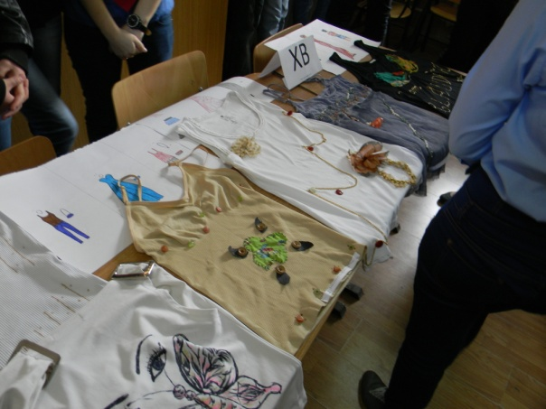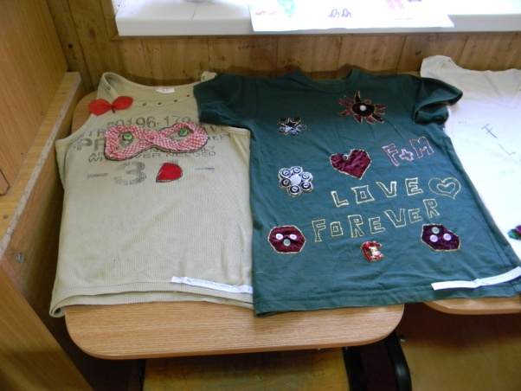
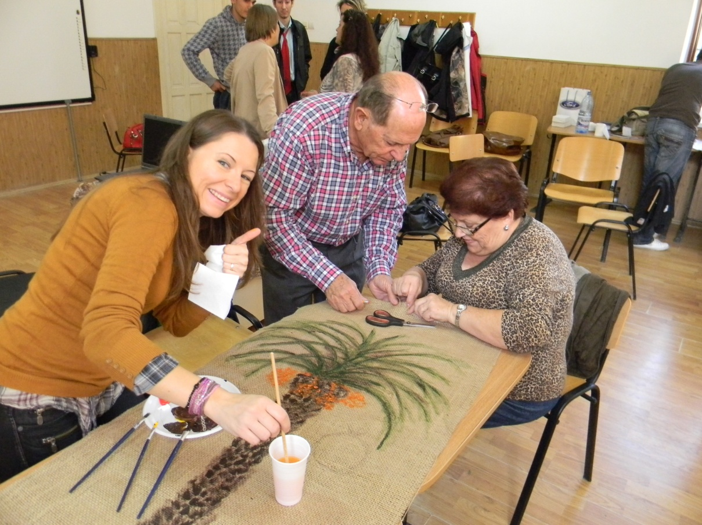
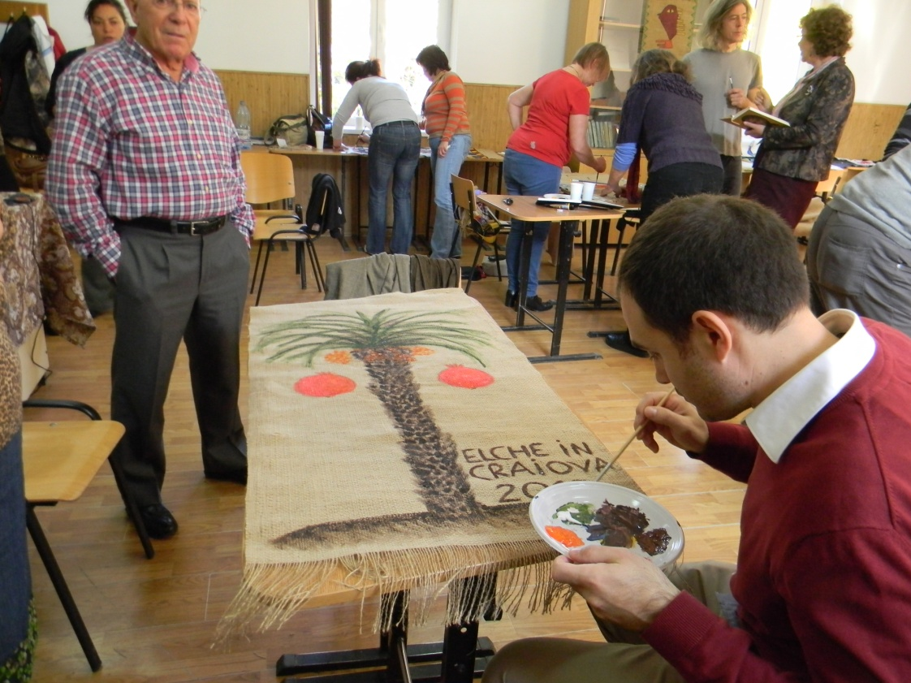
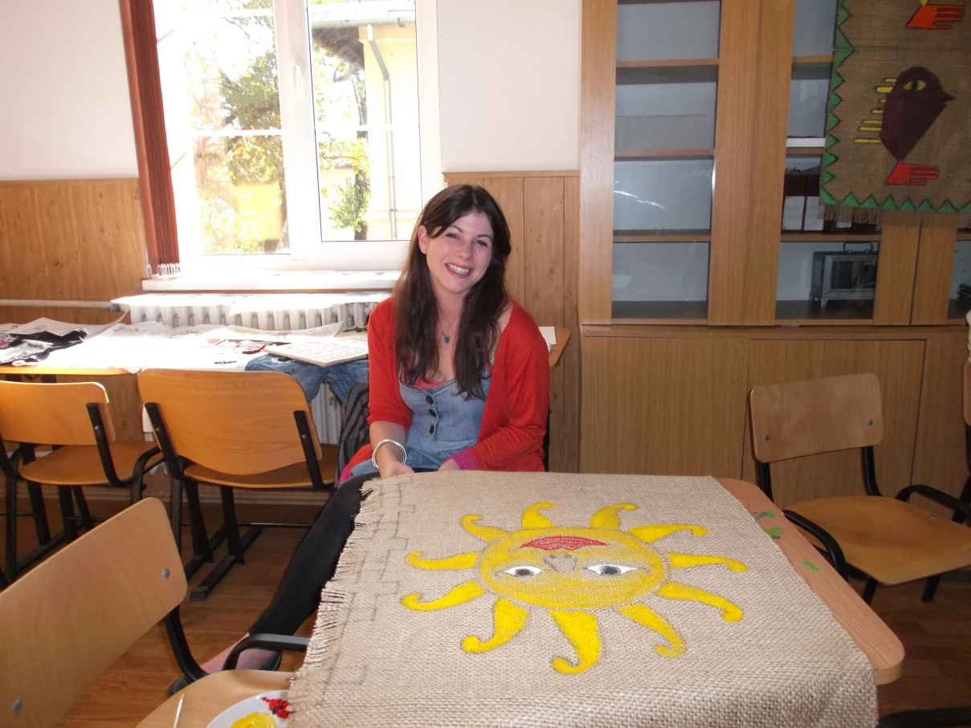
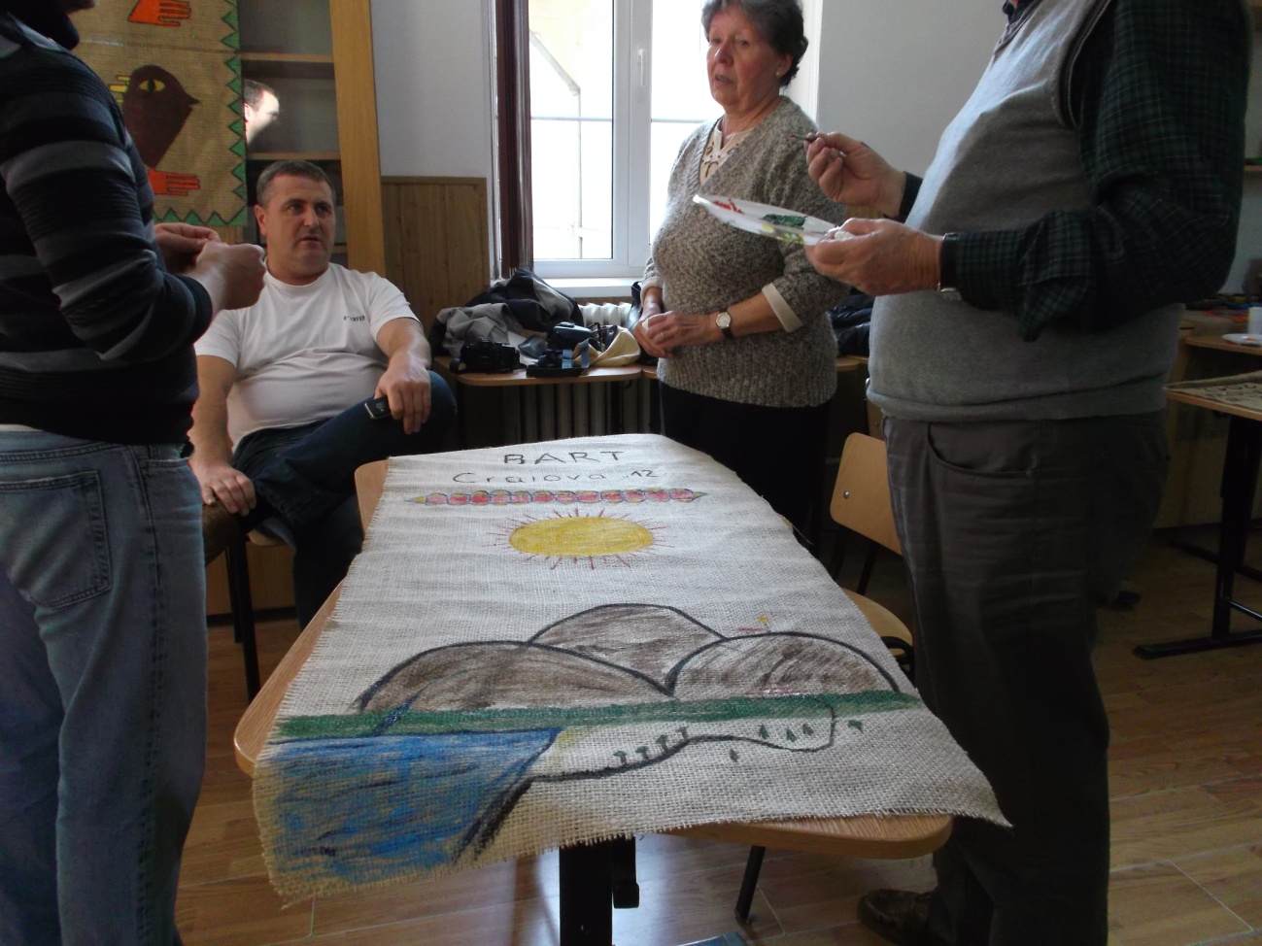
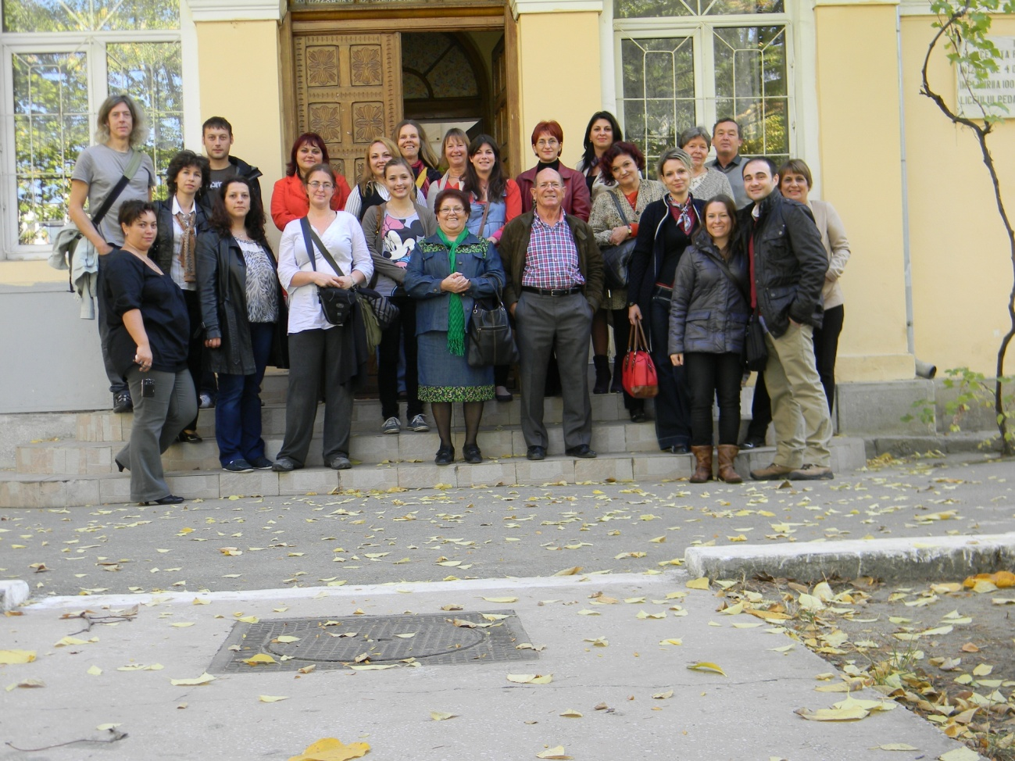
11:00 We go to Craiova downtown. We visit the Craiova handicraft fair.
12:30 We visit a art exposition where art teacher and some students from the schools expose their works.
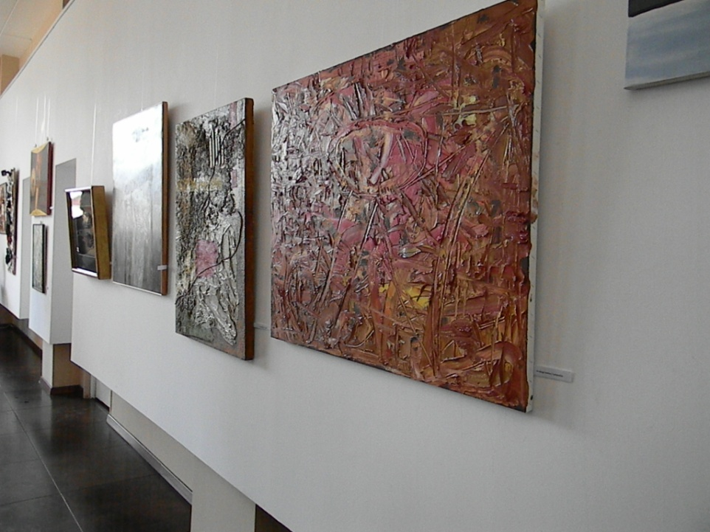
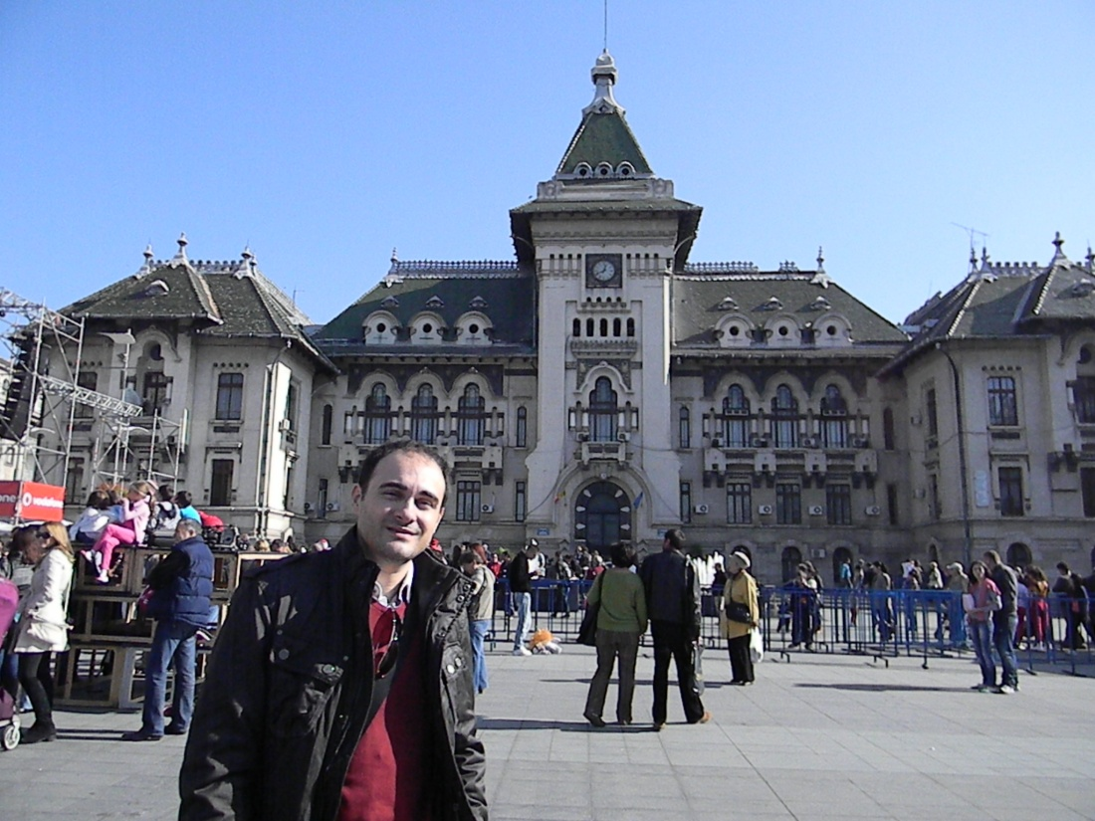
Craiova city council
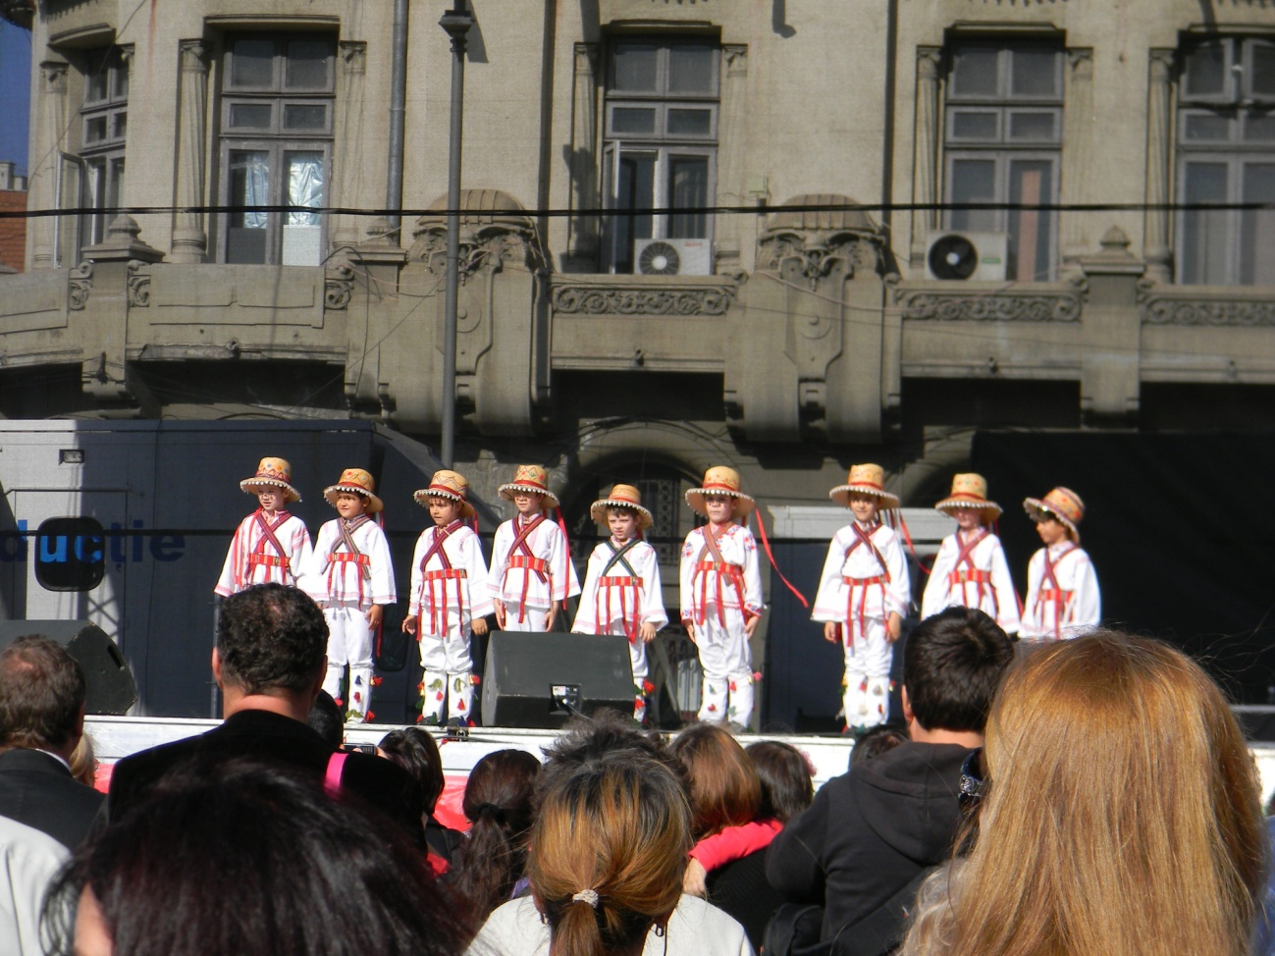
Traditional dance and dressing
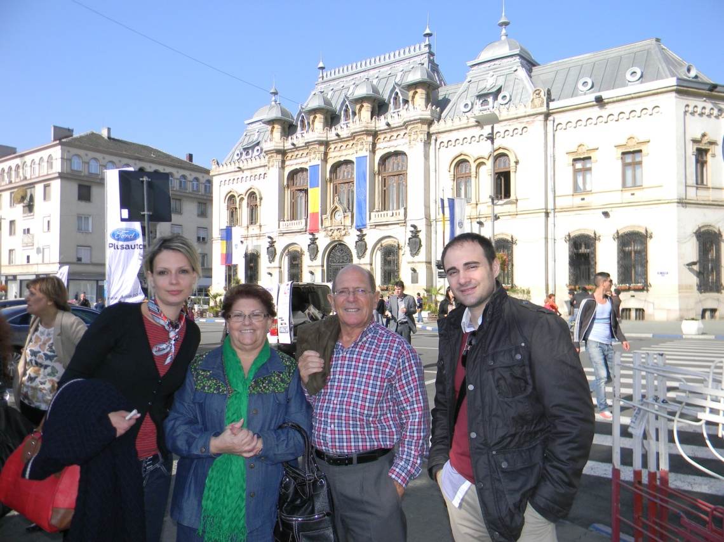
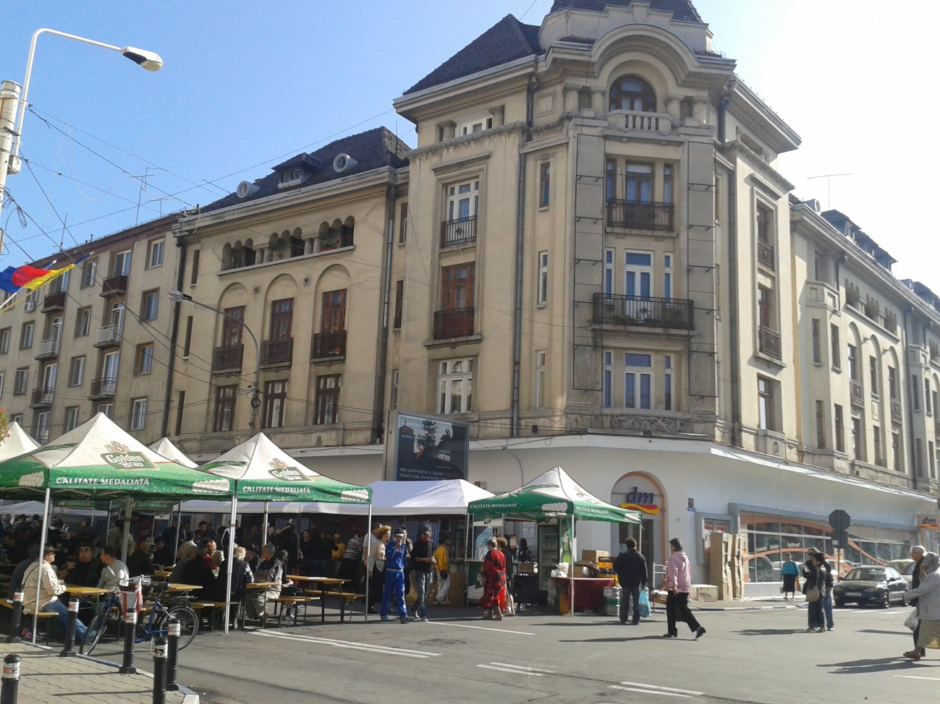
White house in Craiova

Free time
SATURDAY 27th October 2012
We leave Craiova we go to Moeciu.
13:30 Lunch
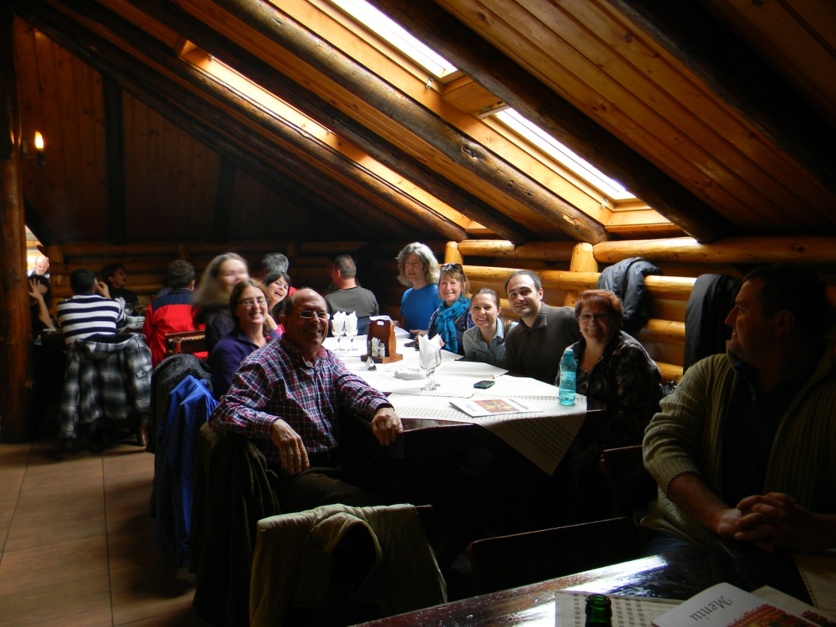
Cheile Gradistei Restaurant
16:00 Visit Castle Bran
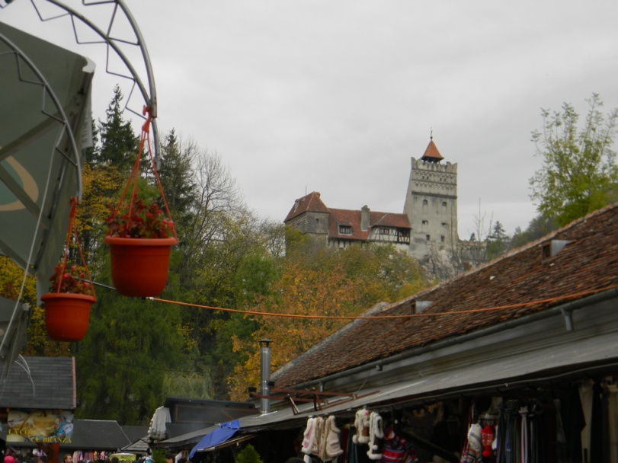
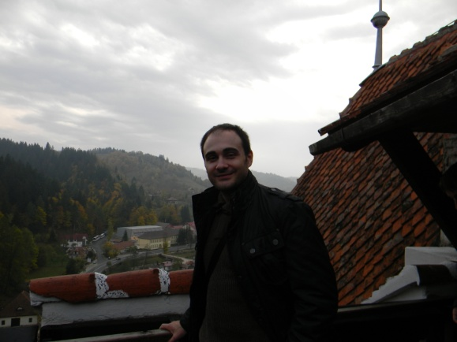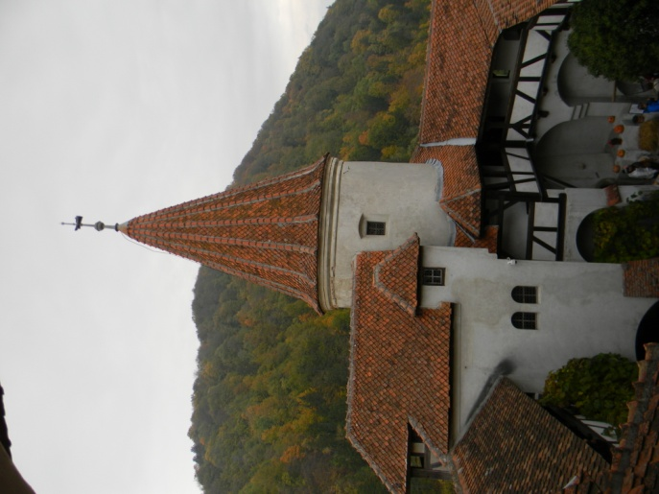
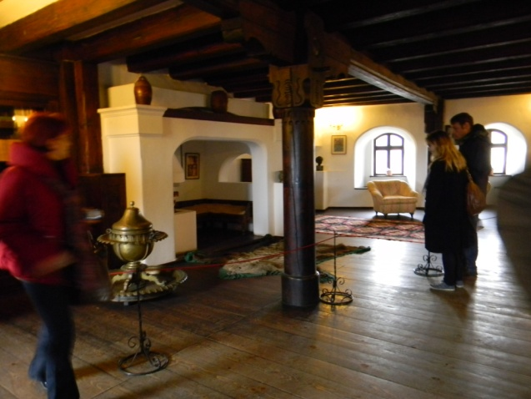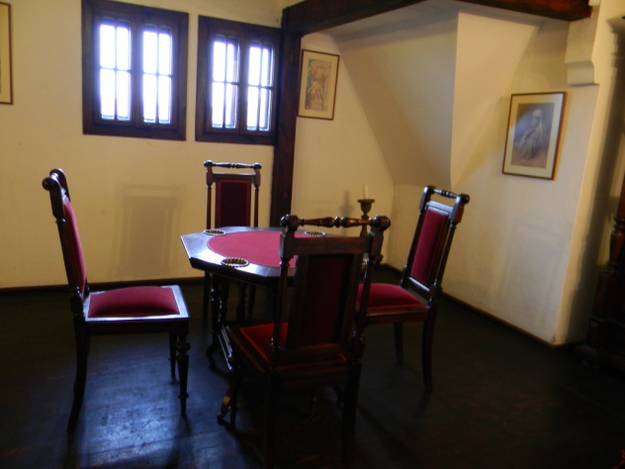
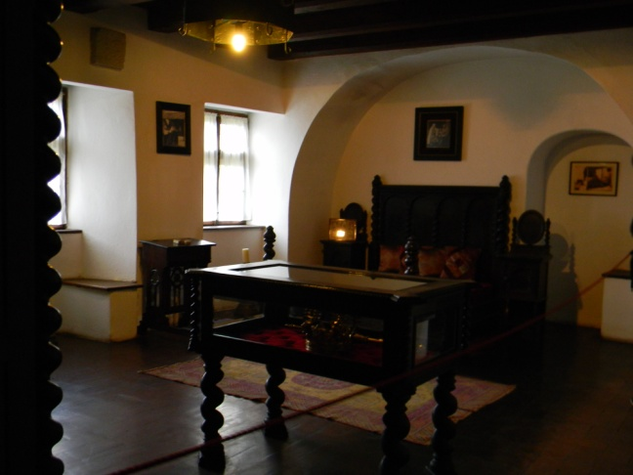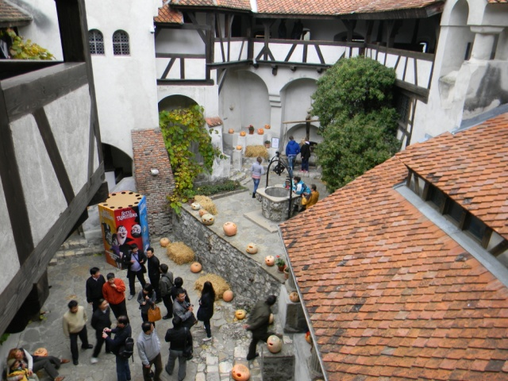
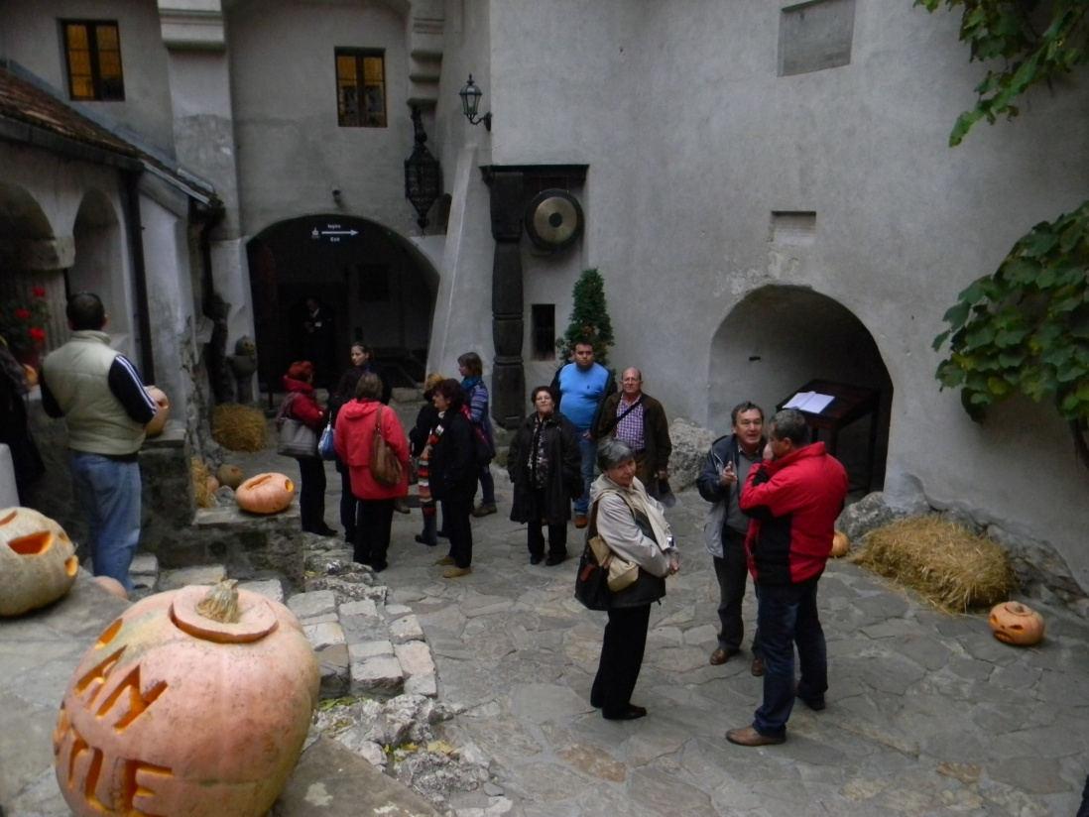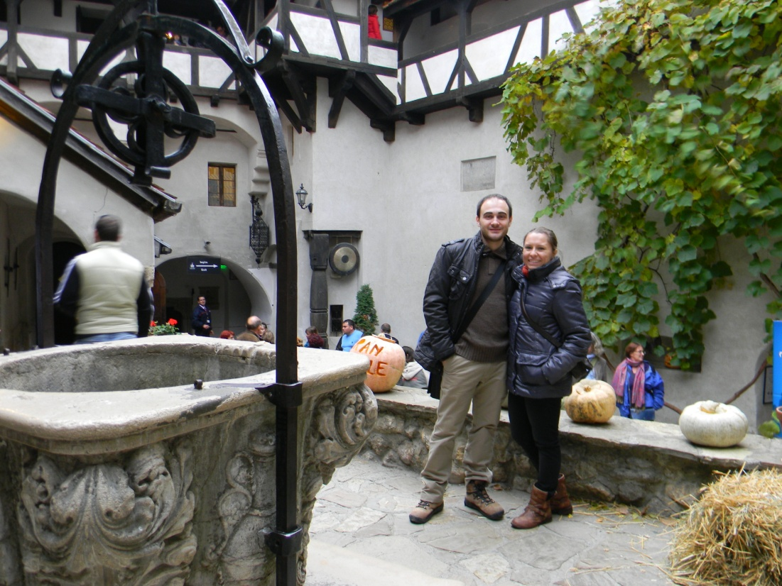
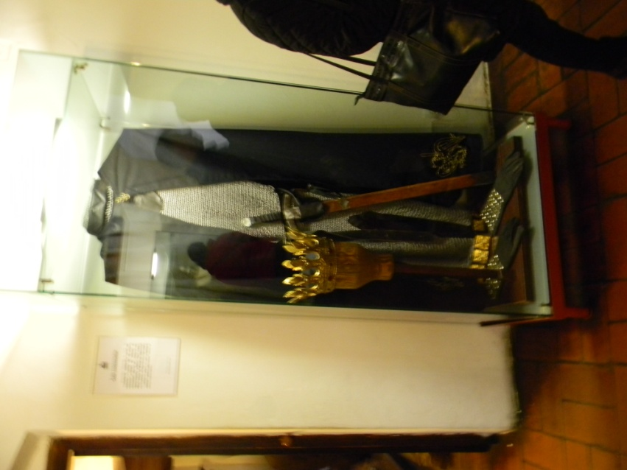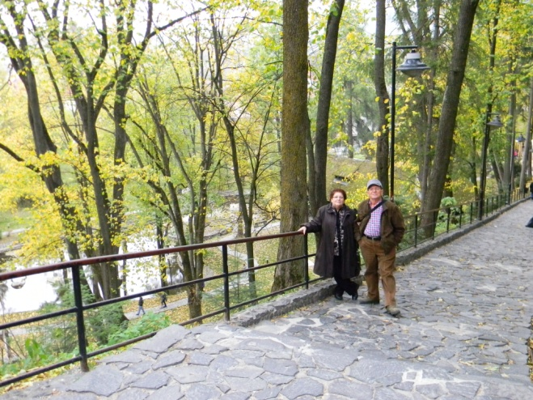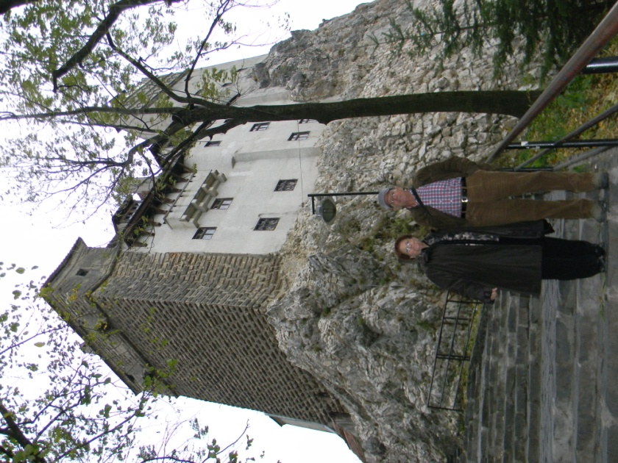

17:00 Visit Castle Bran surroundings and marketplace.
18:00 Check in Pensiunea Orzan.
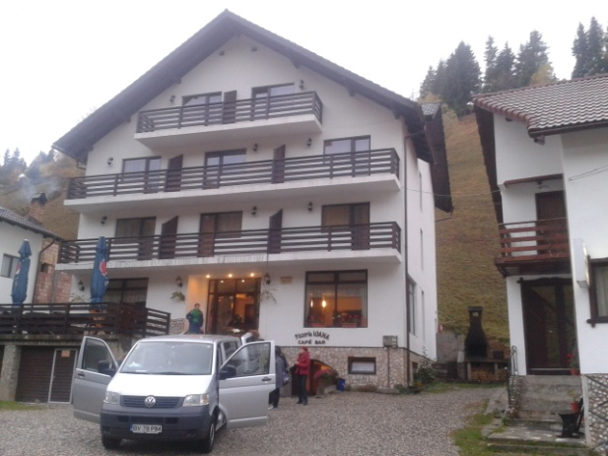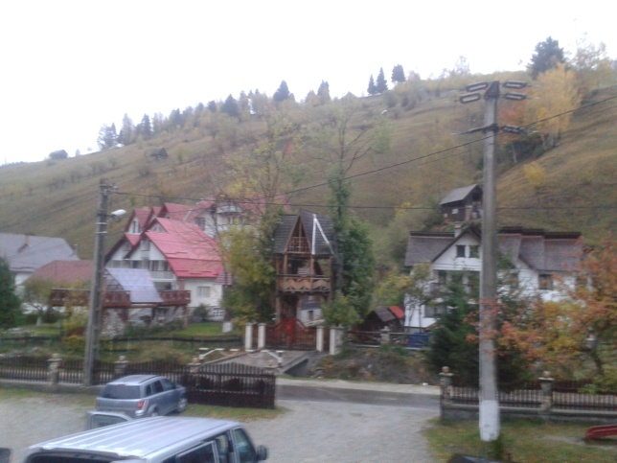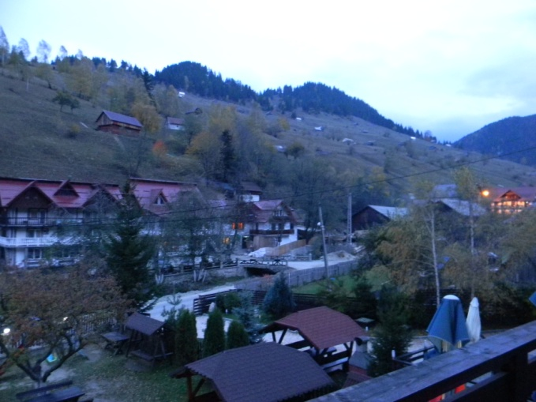
19:30 Evaluation. Feedback. Farewell party. Traditional dancings.
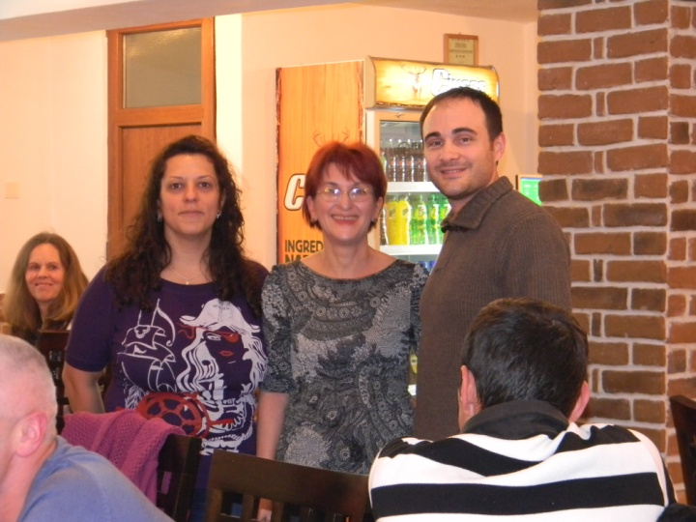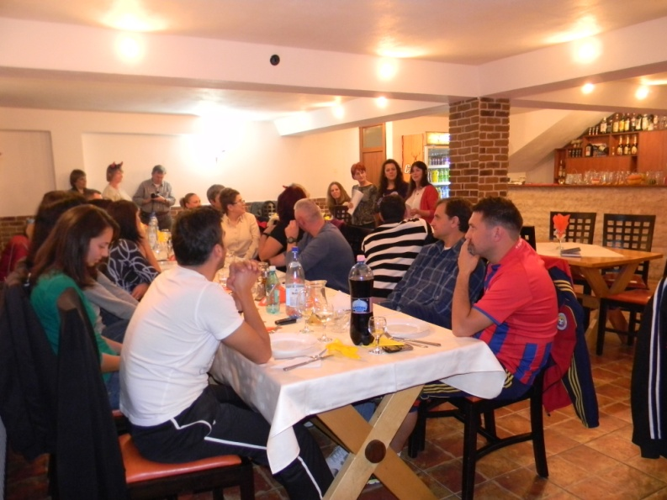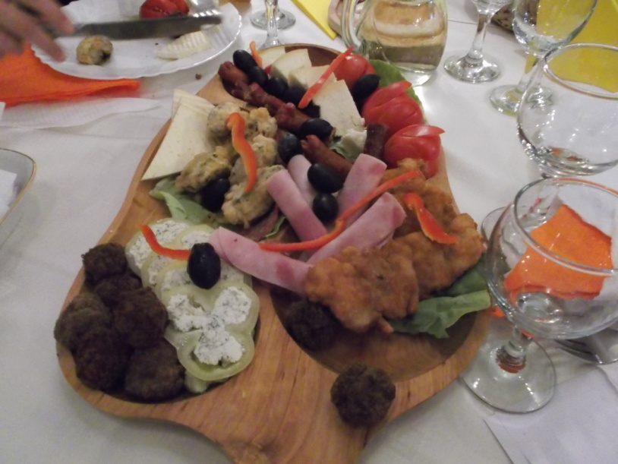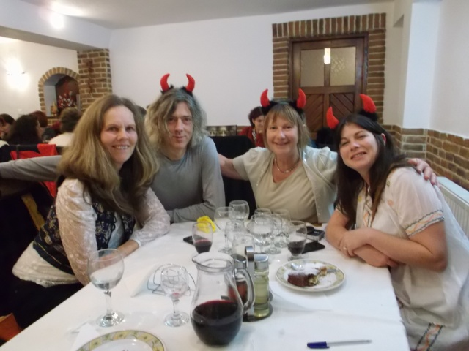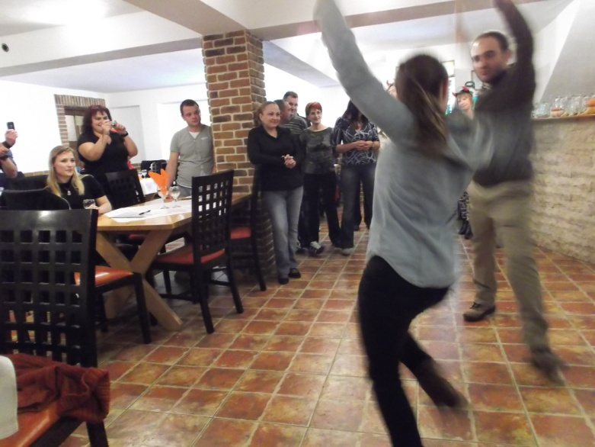
Spanish typical dance called Sevillana
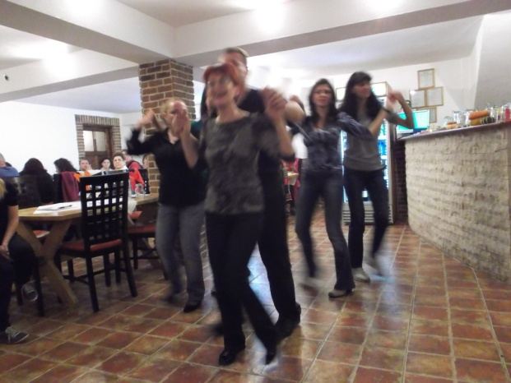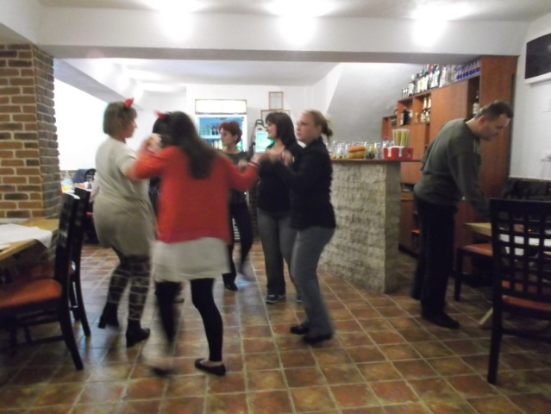
Romanian typical dances.
SUNDAY 28th October 2012
Return to home.

